Plant and Animal Cell Scavenger Hunt

Use the following websites to explore plant and animal cell organelles and their respective functions. Fill in the “Organelle Table” describing the function of each organelle and draw a diagram of that organelle.

Cells Alive
http://www.cellsalive.com/

Cell Inspector
http://www.harcourtschool.com/activity/cell/cell.html

The Virtual Cell Webpage
http://www.ibiblio.org/virtualcell/index.htm

Cell Structure and Processes
http://www.tvdsb.on.ca/WESTMIN/science/sbi3a1/Cells/cells.htm

A Tour of the Cell
http://www.nsf.gov/news/overviews/biology/interactive.jsp

Animal Cell Organelles
http://www.wisc-online.com/objects/index_tj.asp?objID=ap11604

Diagram of an Animal Cell
(please label me)

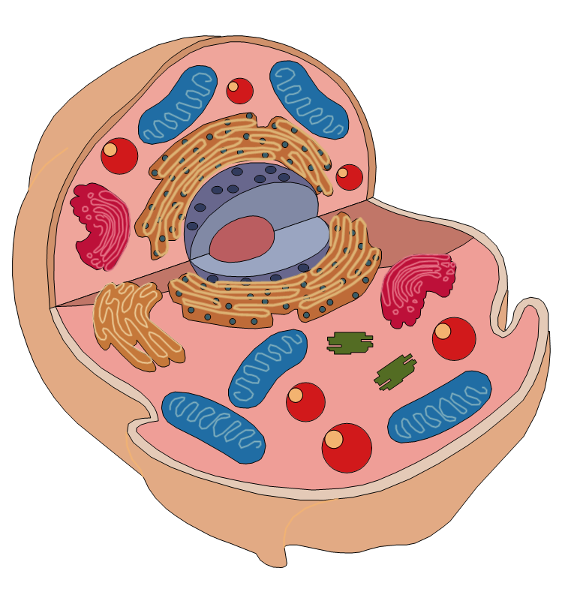
Diagram of a Plant Cell
(please label me)

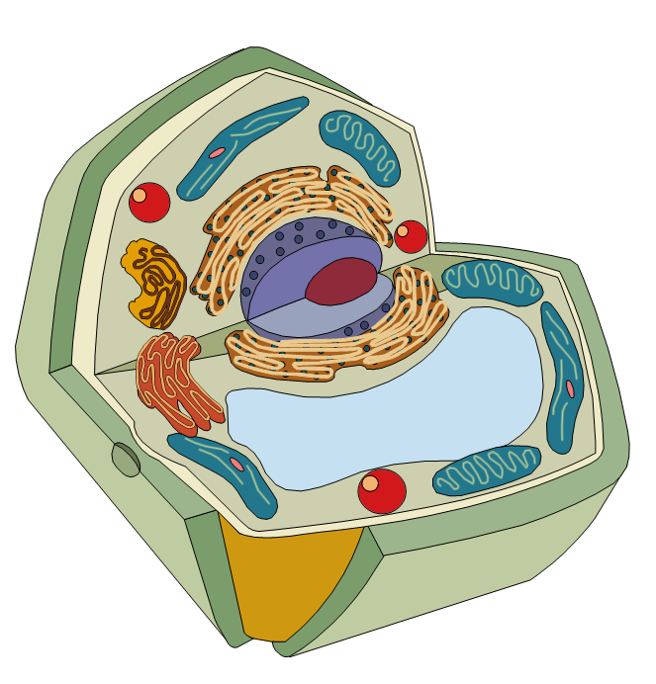

Cell Organelles

Part | Description/Location | Function | Plant/Animal or Both
Nucleus
Cell Membrane
Cell Wall
Vacuole
Chloroplast
Mitochondrion
Chromatin
Nucleolus
Cytoplasm
Centriole
Golgi Apparatus
Endoplasmic Reticulum
Ribosome
Lysosome

