PONDERING PYTHAGORAS

Unit Question: How have mathematical ideas throughout history?

Areas of Interaction: Human Ingenuity

Your task is to explore the history of the Pythagorean Theorem and solve problems based on the theorem. You will then display your findings using whatever display method works best for you.

Part I
- What is the history of the Pythagorean Theorem? Where did the theorem first come from and how did it change and evolve? You may include any information about any of the developers of the theorem and their lives.
- Where is this theorem applied in the world and how has it been applied? You may also consider historical information.

Part II
- You have been presented with a few different visual ways to show the Pythagorean Theorem. Which proof makes the most sense to you and why? How can you display it visually?
- Choose one of the questions and answer it using the proof that makes the most sense to you.

Part III
- Explain how this assignment addresses both of the identified areas of interaction.

Please remember that at least three websites should be visited for each topic area in order to verify your information.

Visual Proofs:
1) http://www.ies.co.jp/math/java/geo/pythasvn/pythasvn.html
2) http://nlvm.usu.edu/en/nav/frames_asid_164_g_3_t_3.html?open=instructions
See also http://www.davis-inc.com/pythagor/proof2.html

Other sites that you might want to explore:
http://www.cut-the-knot.org/pythagoras/index.shtml
http://thejuniverse.org/PUBLIC/MathDesign/Pythagorgrams/index.html
http://www.ies.co.jp/math/java/geo/pythagoras.html
QUESTIONS

1) You are locked out of your house and the only open window is on the second floor, 8m above the ground. You need to borrow a ladder from one of your neighbors. There's a bush along the edge of the house, so you'll have to place the ladder 3m from the house. What length of ladder do you need to reach the window?

2) To get from point A to point B you must avoid walking through a pond. To avoid the pond, you must walk 34m south and 41m east. To the nearest meter, how many meters would be saved if it were possible to walk through the pond?

3) Frank Road and James Road make a perpendicular intersection. The province wants to build a new road. The new road will intersect 3 km north of the intersection on Frank Road and 4 km west of the intersection on James Rd. How long will the new road be that intersects Frank and James Road?

4) Scott wants to swim across a river that is 400 meters wide. He begins swimming perpendicular to the shore he started from but ends up 100 meters down river from where he started because of the current. How far did he actually swim from his starting point?

5) Donna's TV screen is 50cm long. If the diagonal measures 62.5cm, how long is the width of Donna's TV?

6) A carpenter wants to build a handicap ramp over a set of steps that is 4m long and 1.5 m high. How long will the ramp be?

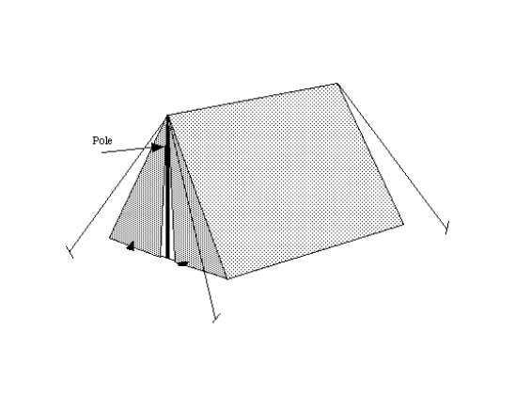
7) A family hiked 3 kilometers north and 4 kilometers east to reach a picnic spot for lunch, but then wanted to find a shorter route home. What options are available to them?

8) Sophia used 2m rope to secure a 1.5m tent as shown. Approximately how far from the base of the tent should each rope be tied?

