Use and Care
of the
Microscope

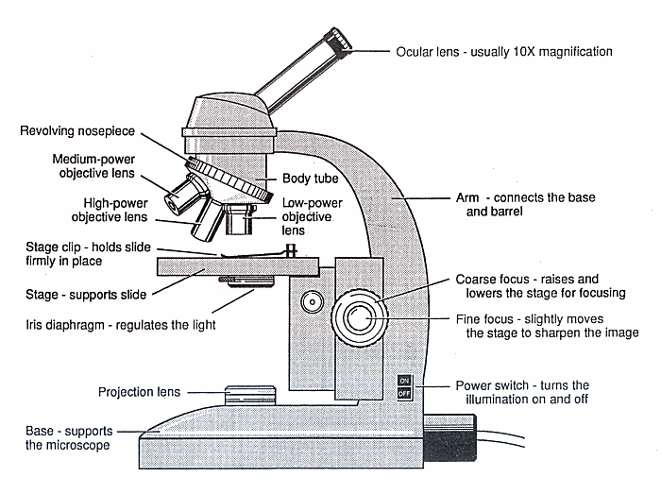

Name:

The Parts of the Microscope

Part | Function
Arm | - connects the body tube to the base  - where one hand is placed while transporting the microscope
Base | - supports the entire microscope
Body tube | - holds objective lenses at one end and the eyepiece, or ocular lens, at the other end
Eyepiece or Ocular Lens | - lens through which you look  - magnifies the specimen, usually by 10x
Objective lenses | - magnify the specimen; three powers to choose from: low (4X), medium (10X), and high (40X)
Revolving nosepiece | - rotates, allowing the objective lenses to be changed and clicked into position
Coarse Adjustment Knob/Coarse Focus | - moves the body tube up and down to bring the specimen into focus  - used only with the low-power objective lens
Fine Adjustment Knob/Fine Focus | - moves the body tube to get the specimen into sharp focus  - used for precise focusing after the coarse adjustment knob has been used
Diaphragm | - located beneath the stage  - regulates amount of light allowed to pass through the stage hole to the specimen
Light bulb | - source of transmitted light needed to illuminate the specimen to be viewed
Stage | - supports the microscope slide  - hole in its centre allows light to pass through the slide
Stage clips | - holds the slide in position on the stage
Power Switch | -turns the illumination on and off
Projection Lens

How to Use Your Compound Microscope
- Always carry the microscope with two hands, one on the arm and the other under the base.

- When lenses are dirty, clean them gently with lens paper and a drop of lens cleaning solution.

- Set your microscope on a tabletop or other flat, sturdy surface where you will have plenty of room to work. The arm should be in front of you. Plug the microscope’s power cord into an outlet.

- Switch on your microscope's light source and then adjust the diaphragm to the largest hole diameter, allowing the greatest amount of light through. If you have an iris diaphragm, slide the lever till the most light comes through.

- Rotate the nosepiece to the lowest-power objective (usually 4x for 40x magnification). It is easiest to scan a slide at a low setting, since you have a wider field of view at low power.

- Place a microscope slide on the stage, either under the stage clips or clipped onto the mechanical stage if your microscope has one. A prepared slide works best when you do this for the first time. Move the slide until the specimen is under the objective lens.

- Look through the eyepiece and slowly turn the coarse adjustment (large knob) towards you (so that the objective lens moves away from the slide) until you see a blurry image.

- Adjust the small fine focus knob until the specimen is clearly in focus. Then adjust the diaphragm to get the best lighting. Start with the most light and gradually lessen it until the specimen image has clear, sharp contrast.

- Scan the slide (right to left and top to bottom) at low power to get an overview of the specimen. Then center the part of the specimen you want to view at higher power.

- Rotate the nosepiece to the 10x objective for 100x magnification. Refocus and view your specimen carefully. Adjust the lighting again until the image is most clear (you will need more light for higher power). Repeat with the 40x objective for 400x magnification.

- Look through the microscope with both eyes open. Your viewing eye should not touch the eyepiece.

- When you finish using the microscope, put the low power objective in place, wrap the cord securely around the microscope, and carefully put it away.

Date of Slide
Name of Slide

Observations

