**BIODIVERSITY TASK**

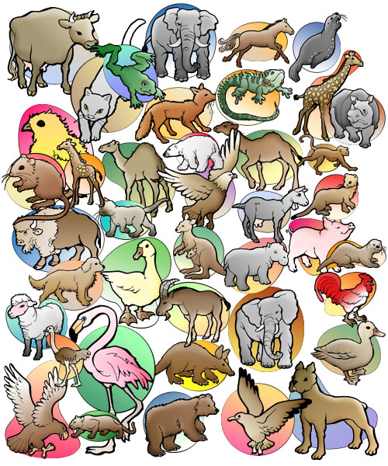

**TASK: You are part of a conservation group that wants to inform the public of the importance of biodiversity. Your group will focus on one specific area of the world. Your conservation group will publish a flyer/poster/advertisement to relay your information. The information that you would like to share includes the following:**

* **What is the name of your conservation organization? Be creative. You may also want to design a logo for your organization.**
* **What is biodiversity?**
* **Why is biodiversity important? In what specific ways does it enhance our lives? Consider the following as a starting point:**
  + **Balance of ecosystems and interrelationships within species and their environment**
  + **Everyday products such as clothing, medicine, food, natural products, household goods**
  + **Economic impact**
  + **Aesthetics**
  + **Importance to resilience of species**
* **What are the threats to biodiversity? Consider the following:**
  + **General threats to biodiversity**
  + **Specific threats to biodiversity in the region that you have chosen to represent. For example, are there any local issues that are the result of human activity, such as forest clearing, mining, overhunting/overfishing, dam construction, residential and commercial development?**
* **What solutions does your organization propose to deal with threats to biodiversity?**

**Assessment Rubric for Biodiversity Assignment**

|  |  |  |  |  |
| --- | --- | --- | --- | --- |
|  | **Level 1** | **Level 2** | **Level 3** | **Level 4** |
| **Explanation of biodiversity and its importance** | Information is not clear. Final product lacks details and does not show an understanding of the topic. | Information included could be clearer. Many additional details are needed to show a satisfactory understanding of the topic. | Information included is mostly clear. Topic is explained well but additional details could have been added. | Information included is clear, concise, and explains the topic well. |
| **Explanation of threats of biodiversity** | Information is not clear. Final product lacks details and does not show an understanding of the topic. | Information included could be clearer. Many additional details are needed to show a satisfactory understanding of the topic. | Information included is mostly clear. Topic is explained well but additional details could have been added. | Information included is clear, concise, and explains the topic well. |
| **Explanation of solutions to threats** | Information is not clear. Final product lacks details and does not show an understanding of the topic. | Information included could be clearer. Many additional details are needed to show a satisfactory understanding of the topic. | Information included is mostly clear. Topic is explained well but additional details could have been added. | Information included is clear, concise, and explains the topic well. |
| **Point form notes** | Student requires much assistance to properly complete point form notes and put information into his/her own words. | Student is still learning how to correctly complete point form notes. Student is still learning to put information in his/her own words. | Point form notes were mostly completed correctly. Information was mostly put in student’s own words. | Point form notes were completed correctly. Information was put in student’s own words. |
| **Paragraphs** | Student requires assistance to correctly write paragraphs without grammatical and/or spelling errors. | Paragraph structure needs work. Many grammatical and/or spelling errors are present. | Information is mostly written in proper paragraph format. Some grammatical and/or spelling errors are present. | Information is written in proper paragraph format with very few grammatical and/or spelling errors. |
| **Final Presentation** | Final product lacks creativity. Project requires considerable more effort in the design and presentation. | More creativity could be shown in final product. Further effort was required in the design and presentation. | Final product shows some creativity. Project is mostly designed and presented well. | Final product shows creativity. Project is designed and presented well. |