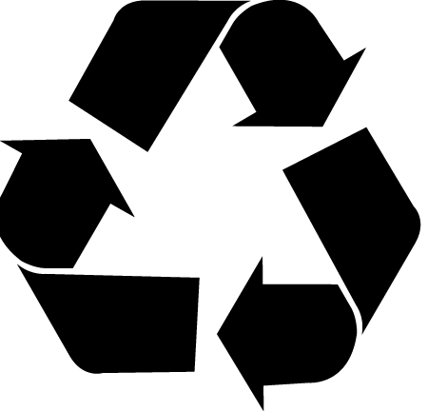
Critical Thinking Assignment 2
Recycling

Goal: To determine if recycling has more disadvantages or advantages.

Gather information: Working as a group, you will gather information on the issue. Use as many sources as possible. Remember that is it important to seek accurate information when doing research. Below are some suggested sites to use.

Identify Solutions:
- Explain how garbage is currently sorted in Toronto (or Ontario) and what is done with material that is potentially recycled.
- Use appropriate vocabulary to describe and effectively discuss the benefits of, and potential risks of recycling vs. landfill (Group C advantage, Group D disadvantages)
- Identify alternatives to recycling or landfill (what are the advantages and disadvantages of each) (Group C advantage, Group D disadvantages).
- Discuss critically some of the issues that surround recycling issues
- Keep in mind social implications, economic implications, cultural implications, moral/religious implications, philosophical implications (how does this relate to our idea of justice?)

Make a Case: Are the advantages of recycling worth the costs? Are there other alternatives to recycling that are more cost effective? How did you decide?

Communicate: With your group, prepare a presentation to convince the rest of the class of your case. Decide how you will make your presentation: a brochure, a video, a poster, etc. Your report should include the following information:
- Benefits or costs/risks of recycling
- Information on the issues surrounding recycling
- Alternatives to recycling
- Implications of recycling
- Your opinion on what our city should do about them.
Present your report at our town meeting. Other groups will also present their reports and we will have a vote on the issue.
Some resources to help you in your search:
- Nelson p.62
- Advantages & Disadvantages http://wiki.answers.com/Q/Advantages_and_disadvantages_of_recycling_materials
- Urban Waste Management: http://www.gdrc.org/uem/waste/disposal.html
- Fact Sheet for Kids: http://www.chevroncars.com/learn/wondrous-world/recycling-facts
- Fact Sheets: http://container-recycling.org/facts/all/?gclid=CPKntqm1zJwCFado5QodXymPJw
- Fact Sheets: http://www.justthink.org/going-green/?gclid=COuB6bO1zJwCFWJB5godmnyzJg
- Green Blog: http://www.bestgreenblogs.com/category/recycling-issues/
- Environmental Issues Article: http://environment.about.com/od/recycling/a/benefit_vs_cost.htm
- Recycle or Landfill? Blog: http://thegogreenblog.com/recycle-or-landfill/

Possible Student Research Sites
www.nytimes.com/learning/students/index.html
www.washingtonpost.com/wp-dyn/kidspost/
www.pbs.org/newshour/extra/
www.npr.org
www.newseum.org/index.htm
www.timeforkids.com/TFK/index.html
news.bbc.co.uk/cbbcnews/
www.headlinespot.com/for/kids/
www.cnnstudentsnews.cnn.com/fyi/index.html
teacher.scholastic.com/scholasticnews/news.index.asp
www.publicagenda.org/sitemap.htm
www.urbandebate.org/resources/

