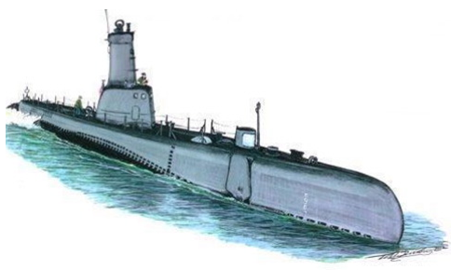
Ballast Water Management

Unit Question - How does our understanding of properties of fluids affect our lives?
In this task students will investigate a problem associated with human application of density and buoyancy. Students will creatively present their findings about the problem and its affect on our environment.

The Task
- Investigate the problems and solutions associated with ballast water management (begin by taking point form notes and organizing them into topics - your point form notes must be handed in with your good copy)
- Creatively present your information through the viewpoint of one of the involved members of the ballast water management problem

Information to Include
- What are the problems of ballast pollution? (Through the use of ballast tanks, how have humans affected ecosystems and environments? How are humans, in turn, affected?)
- How does this problem affect different members of society? (Do all members of society view it as a problem? Are there those who “ignore” the problem?)
- What are some solutions to this problem? (Is it possible to reduce the amount of pollution that goes into water systems from ballast tanks? What are the viewpoints of different industries? How do ballast laws affect the various groups involved? What factors will make this process difficult? Consider social, economic, political, environmental, and ethical implications.)

How to Present
- Create a presentation using any appropriate presentation form (please have it approved)
- Your presentation must try to convince others that either (i) using ballast water is good, or (ii) using ballast water is bad
- Ideas for presentation include but are not limited to: print advertisement for magazines or newspapers, radio advertisement or public service announcement, website/blog, editorial article, captain’s log, letters to various organizations,

Timeline
Point form notes to be completed by
In-class work periods
Final Due Date

Final Presentation Must Include
- Point form notes
- Hard copy of information (scripts must be presented for any oral presentation) and digital copy, if appropriate
- Bibliography information

Ballast Water Management Rubric

Criterion A – One World

Achievement Level | Descriptor
0 | You do not reach a standard described by any of the descriptors given below.
1-2 | You state the problems and solutions associated with ballast water management.  You state the effectiveness of science and its application in solving the problems associated with ballast water management.
3-4 | You state the problems and solutions associated with ballast water management.  You state the effectiveness of science and its application in solving the problems associated with ballast water management.  You state the implications of the use and application of ballast water management with two of the following factors: moral, ethical, social, economic, political, cultural and environmental.
5-6 | You describe the problems and solutions associated with ballast water management.  You describe the effectiveness of science and its application in solving the problems associated with ballast water management.  You give examples and describe the implications of the use and application of ballast water management interacting with at least two of the following factors: moral, ethical, social, economic, political, cultural and environmental.

Criterion B – Communication in Science

Achievement Level | Descriptor
0 | You do not reach a standard described by any of the descriptors given below.
1-2 | You use a limited range of scientific language correctly when describing problems and solutions associated with ballast water management.  You communicate scientific information with limited effectiveness.  You make little attempt to document sources of information.
3-4 | You use some scientific language correctly when describing problems and solutions associated with ballast water management.  You communicate problems and solutions associated with ballast water management with some effectiveness.  You partially document sources of information.
5-6 | You use sufficient scientific language correctly when describing problems and solutions associated with ballast water management.  You communicate problems and solutions associated with ballast water management effectively.  You fully document sources of information.

Note: A communication rubric takes the following into consideration:
- Sentence structure (written or oral)
- Paragraph organization
- Clarity of writing (written or oral)
- Effective delivery of message (written or oral)

